Transforming responses to Complex Needs

Introduction

The Making Every Adult Matter (MEAM) coalition produced a discussion paper defining complex needs as people that have two or more of the following problems – substance misuse, offending, homelessness and psychiatric illness. The MEAM definition has become accepted nationally and is informing local commissioning plans around complex needs all over the country and locally in Plymouth. However, because complex needs services typically contain a range of people with some having a single issue and others all four of the MEAM issues, any whole system change will necessarily impact on the whole cohort. We are therefore including services for people with one or more of the MEAM issues, rather than two or more.

Plymouth participated in the bidding process for the BIG Lottery during which we carried out a huge consultation with services and the people that use them. As a result commissioners, services and the people using those services concluded that parts of the system were highly dysfunctional. Targets were disparate and set-up perverse incentives, there was little or no synergy between commissioning strategies, competition militated against co-operation to the detriment of people using services and thresholds and boundaries had little utility other than as a means of excluding people from services. At that time the MEAM coalition were advocating a system of link workers to help people navigate between services and advocate on their behalf. The Plymouth group felt this approach did not address the fundamental problems in the system and so opted for different approach.

We were unsuccessful with the lottery bid but felt the issues were so important that we would continue the work with a view to transformational change towards a whole system approach with the needs of the end user at the centre of the process.

Consultation feedback
Silo working
As part of a Big Lottery bid in 2012 over 400 service users, 70 services and several key individuals were consulted with, including political leaders and senior executives. The consultation uncovered the widely-held view that services are delivered in ‘silo’s’ - essentially narrow systems that do not relate to the needs of people that use services or effectively join-up with other silos of care that the person may need. These silos of service delivery are essentially, a result of a commissioning process that has hitherto been mechanistic and more akin to a model of centralized procurement than a genuinely inclusive, collaborative and end user focused process. In other words rather than commissioning being a means to achieve efficient and effective delivery it has instead ‘set’ many of the barriers to integrated care, some of which are listed below:
- Commissioning seen as top-down, opaque, and disempowering process for services
- ‘Master – servant’ relationship rather than an inclusive, outcome-based partnership between commissioners, services and people using services.
- Commissioning is enforcing processes that are bureaucratic and squeeze staff delivery time
- Contracts are over-specified leaving little room for innovation
- Where there is consultation it is too late in the process i.e. it does not allow stakeholders to influence and ‘own’ the vision for patterns of service.
The consultation also disclosed problems with and between services that, at least in part, flow from commissioning practice. The competitive nature of tendering militates against the co-operation, collaboration and joint-delivery that people using services need, setting-up a significant disincentive to sharing approaches or new ways of working that may give an advantage in a competitive tendering process. In addition, people using services described their experience of services as non-inclusive, feeling things are ‘done to’ rather than ‘developed with’ them and that too often their use of a particular service makes it hard to use other services, because they are effectively, ‘owned’ by the original service silo. A lack of agreed data sharing or care management between services also means people have to tell and re-tell their stories multiple times to many people. Lastly, the consultation and research showed clearly that people in services frequently have multiple problems but the silo’d approach either doesn’t recognise this complexity or when it does, is powerless to deliver the integrated solutions required for the reasons set out above.
Two subsequent co-production events – the Big Buzz in 2015 (148 participants) and Growing for Life in 2016 (258 participants) have repeated the original findings and people using services have asked for;
Big Buzz
- Hubs/multiagency access points where service users could get all of their needs met
- Mental health services to be restructured and have parity of esteem
- Better information sharing
- Suitable accommodation options, especially for people with complex needs
- Shared/common needs assessment
- Supporting the ‘whole’ person
- Timely interventions.

Growing for Life
- Better access to Mental Health Services
- Co-location of Services
- Consistency of Staff – Relationship Building
- Time and Flexibility (for services not to be time limited)
- Prevention.

Skills and Specialisms
In addition to the ‘broad brush’ findings of these consultations some of the themed sub-groups and subsequent meetings between commissioners and providers have revealed more specific issues. Despite the fact that many services describe themselves as ‘specialist(s)’ our discussion and analysis shows that in most services, most of the work most of time is general health and social care work – support, care, relationship building, guidance, signposting etc. In addition, services will describe themselves as, for example, a specialist homelessness provider and highlight the fact that 70% of their clients have a substance misuse issue which, traditionally, would be seen as a different specialism. In fact, viewed through a whole system lens, if 70% of a housing provider’s caseload has a drug or alcohol problem it is core issue for that service. What the provider is actually describing is a workforce without the necessary core skills to manage its caseload effectively. Across the system we see that core skills are often characterised as specialist and are contained in a particular silo. Instead those skills should be more widely disseminated throughout the system, reducing the numbers of people handed-off or referred on to other silos. Core skills include (but not limited to)
- Risk assessment, risk management and mitigation (the single biggest cause of inter-service hand-offs)
- Motivational interviewing
- Relapse prevention
- Mental Health first aid, Basic Mental Health Assessment
- Basic CBT skills
- Substance misuse assessment

Cost of complex needs
- As a result of changes in welfare reform and increasing health inequalities, there are a growing number of people experiencing addiction, homelessness, offending and poor mental health. This in turn is likely to impose greater costs on the state, with recent research finding that £19,000 per person per year is spent on individuals facing a combination of these problems

Scale of the Task

Local demographics

Local information, combined with national modelling indicates that adults experience complex needs at different levels, as follows:
- A core group of approximately 270 requiring intense support for a number issues at the same time
- Approximately 3000 people that are not in immediate crisis but could fall into core without intervention and receive sub-optimal treatment due to their complexity
- Approximately 5000 people who have complex needs but are stable and engaging with support.

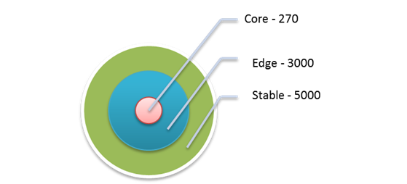

Plan
We are currently running two related but parallel processes, firstly preparing the ground for re-commissioning through a competitive process and secondly optimising current ‘in contract’ performance.
Commissioning in 2018
In order to commission a new system of care for people with complex needs it is necessary to;
- identify all the contracts that are ‘in scope’
- negotiate agreement to do something different with the various commissioning organisations
- Ensure all the contracts are synchronous through contract extension to an agreed date (2018)
- Identify appropriate contract options for the new system eg alliance contracts

Contracts in scope

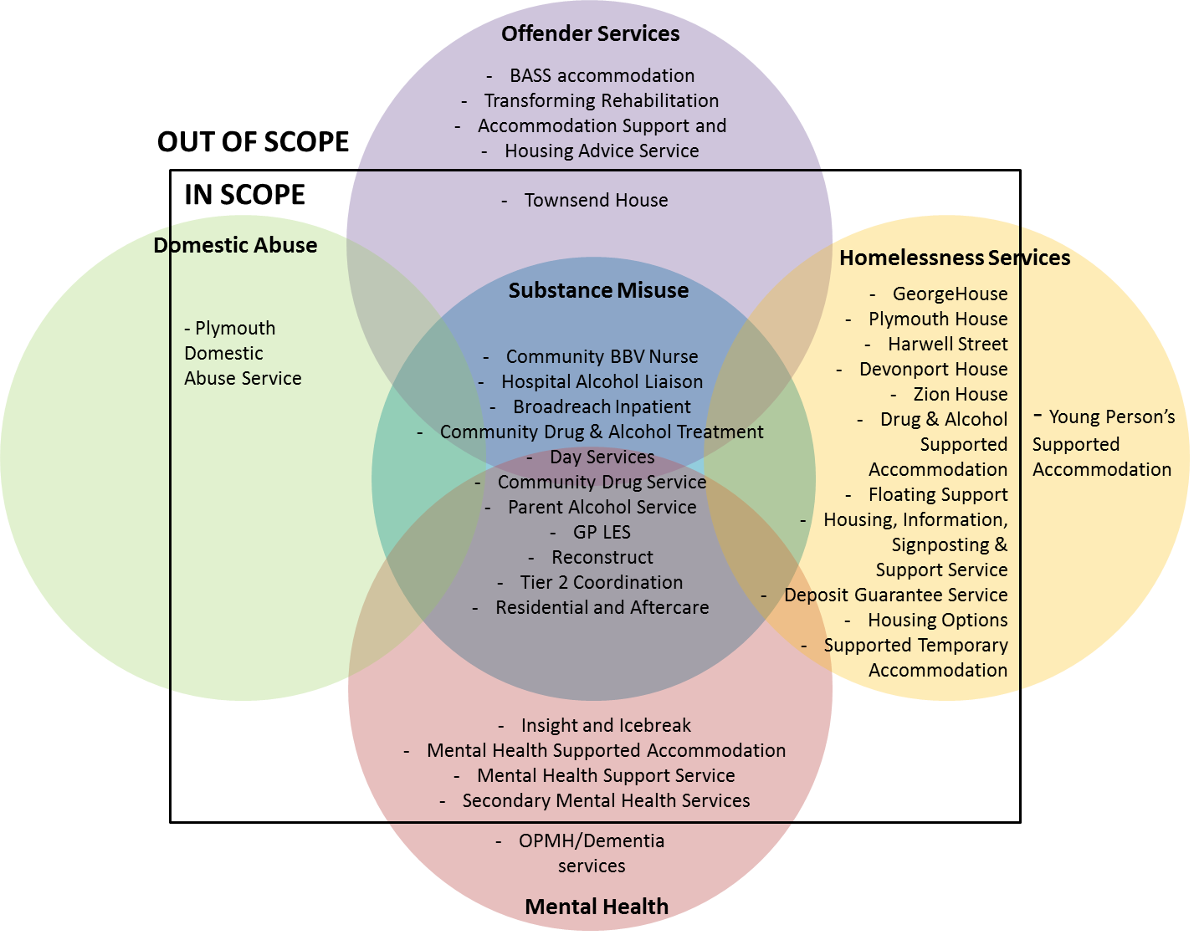
At present we have extended all the contracts and agreed everything in scope apart from the detail of mental health provision. This is complicated by the fact that the MH contract serves a wider geography than Plymouth and is commissioned by the CCG which has a wider remit than Plymouth. Rather than destabilising a wider mental health service by allocating particular contract values or services to our integrated commissioning plan, we have instead reached agreement with the CCG that we can collaboratively re-model any care pathways that will support the complex needs work.

Broad aims of new system post 2018
In response to consultation and needs analysis, there is an opportunity to remodel and review services across substance misuse, offending, homelessness and mental health and make recommendations to:
- Create a ‘whole system’ approach that meets the needs of clients with a singular support need whilst also providing an improved offer to clients with more complex needs. Need fluctuates and therefore requires a system that can flex and change according to individual circumstances
- Develop a more efficient system through a collaborative model of support that reduces duplication and delivers an improved client experience with positive outcomes
- Create a contractual environment where suppliers share responsibility for achieving outcomes and are mutually supportive, making decisions based on the best outcome for the people using the service(s)
- Develop the workforce to ‘up skill’ generic support staff to deal with typical presentations, enabling specialist services to be more targeted whilst improving service delivery and outcomes.

This will help to achieve the following outcomes:
- Enable people to access the right support at the right time and reduce repeat presentations
- Reduce homelessness
- Increase levels of employment
- Increase levels of substance misuse recovery
- Reduce re-offending
- Reduce A&E emergency attendances
- Reduce the number of hospital admissions and length of stay.

Optimisation of the Current System
Providers who support people with multiple needs report key challenges around increases in complexity, issues accessing sustainable accommodation, disjointed working, challenges sharing information and managing risk and missed opportunities for timely interventions.
We recognise that it is important that any improvements for people with multiple needs that can be implemented immediately are not delayed whilst a wider system redesign process is undertaken. Therefore we have been working with providers who have an interest and the ability to make changes to the current system to make it more efficient and effective, produce better outcomes for service users and deliver financial efficiencies.
Our values
We recognise that commissioners, providers and people using services are participating in a shared endeavour to improve the experiences and outcomes of people in the complex needs system. Whilst we may have different roles and responsibilities we are committed to sharing power and control in order to achieve a collaborative advantage. In our model leadership is paired with ‘followship’ and is shared throughout the group on a topic by topic basis. The best/most skilled person on any given topic will lead regardless of their hierarchical position or role and we encourage ‘followship’ – where regardless of hierarchical position or role, we all commit to being constructive and positive followers. The SOG also enables us to construct bespoke methods of enquiry and examination of problems rather than dogmatically applying a single method of enquiry to every problem.
We communicate openly and honestly and ensure our discussions and processes are transparent. There are no taboo subjects and any area of the complex needs system from vision to delivery may be discussed. However, discussion will be about ideas, concepts, processes etc not about personalities or individual people.
System Optimisation Group (SOG)
The first System Optimisation Group took place in October 2015 with a range of 16 organisations who attended and will continue to meet on a monthly basis. Key functions of the group include:
- Defining the issue; who are the people who fall between the gaps, what issues do they face, how many are in this cohort
- Problem solving; identify immediate solutions to meeting the gaps in our system
- Fixing what can be fixed now; members will be expected to make changes within their organisations
- Ensuring that the views of people using services are represented
- Sharing Good Practice
- Ensuring that recommendations for system changes that cannot be implemented within the existing system are communicated to commissioners.
- Identifying where efficiencies can be found (timescales and approximate amount to be confirmed).
The System Optimisation Group’s members are key decision makers within their individual organisations and they are committed to making decisions based on what is best for the people using the service.
As a system, they have identified the key challenges they face when supporting clients with complex needs, these include:
- Accommodation: lack of access to quality, affordable, long term solutions
- Levels of complexity: clients have multiple support needs and but may not meet thresholds of services eg mental health because thresholds tend to be based on diagnosis or primary label, rather than on presenting need
- Disjointed working: services currently work in silo’s, perform repeated assessments and experience limited partnership working
- Managing risk: different thresholds for risk, lack of cross organisational information sharing, managing high risk service users, particularly in accommodation
- Timely support: services are often time limited and service users experience lengthy waiting lists, causing an opportunity to deliver the right intervention at the right time to be missed
- Strategic planning: services experience lack of transparency over the whole system resource and short term planning that is unable to respond to changing need.

Feedback from the System Optimisation Group indicates that we have a varied workforce; however there is no common standard for a generic support worker and there is potential to train the workforce and reduce the number of specialist roles required. This would require a programme of transformation but would enable staff to move flexibly around a complex needs system, providing continuity of support.
Early successes
As a complex needs community we were able to achieve savings of £500k through open discussion with providers. These were accrued through a range of suggestions advanced by providers notably vacancy freezes and some reduced management costs. There was also agreement to ‘job match’ people so staff can work across the system when some of the frozen vacancies need back-filling or sickness or absence raises a short-term gap. For example, staff from housing agency A may work temporarily in housing agency B to provide cover, avoid the need for agency staff etc.
The group has agreed to using a common core assessment and common core confidentiality and these are currently being piloted. They are used to reduce the number of times people have to tell their story and are accepted as a trusted assessment between services so people can access interventions more efficiently.
The historic housing pathway was commissioned as stages 1,2 and 3 and the SOG agreed that this is too linear a conceptualisation and does not represent need on the ground. Instead we agreed to scrap the staged approach and move to an entirely individualised system where a person will be housed according to their presenting need/assets and personal choice.
Many services are now either co-locating staff with partner agencies or running regular ‘clinics’ or drop-in sessions in each other’s buildings. In addition, we are in the early stages of discussion about adding value to CCG plans for ‘at scale’ primary care services. We would be looking to deploy all of our services in support of the two proposed ‘super-hubs’ delivering both a long-term focus on reducing inequality in our poorest wards whilst also working to reduce hospital admissions.

Prepared by
Gary Wallace and Sophie Slater

