Mindfulness sessions for parents of people with learning disabilities – impact on depression, anxiety and stress

- A four week Mindfulness Based Stress Reduction course consisting of two hour sessions per week for families which include someone with learning disabilities or autism was held at Talbot House in November and December 2016. The sessions covered: deep relaxation, mindful breathing, mindful walking, the 3 step Breathing Space, mindful eating and mindful communication.

- The mindfulness course was facilitated by Dene Donalds who has been practicing mindfulness since 1995 and facilitating mindfulness groups since 2003. Dene has completed training as a teacher of Mindfulness Based Stress Reduction at Bangor University and is also an Ordained Zen Teacher.

- The mindfulness course was funded and supported by the National Family Carer Network, the Greater Manchester Joint Training Partnership and Talbot House.

- The short-form Depression Anxiety Stress Scale (DASS-21; Henry and Crawford, 2005) was completed by participants at the initial mindfulness session and final session four weeks later. The DASS-21 is a 21 item questionnaire with three 7-item subscale measures of depression, anxiety and stress over the previous week. Participants respond using a four point Likert scale ranging from 0 (“did not apply to me at all”) to 3 (“applied to me very much or most of the time”). Scores are then doubled to be comparable with the full DASS which has 42 items; therefore the DASS-21 measure yields a total score between 0 and 126, with each subscale yielding a total score between 0 and 42.

- Six people completed pre and post DASS-21 questionnaires at the initial and final mindfulness sessions; four women and two men.

- Total and subscale scores reduced for each participant except in three cases (rises in anxiety subscale score for Participant 4 and Participant 6; no change in depression subscale score for Participant 6) – as shown in the graphs below (p3-5).

- As a group the participants showed statistically significant reductions in the total DASS-21 score, depression subscale score and stress subscale score. There was a reduction in the anxiety subscale score but this did not reach statistical significance. Further details are given below (p2).

Pre-post changes in DASS scores

 | Pre  Mean | Post  Mean | Change in Mean | Paired samples t test Significance (two-tailed)
DASS – total score | 54.33 | 30.33 | 24.00 | 0.016
DASS - depression | 16.67 | 10.00 | 6.67 | 0.031
DASS - anxiety | 13.00 | 8.33 | 4.67 | 0.239
DASS – stress | 24.67 | 12.00 | 12.67 | 0.008

As a group, participants showed significant reduction in total DASS-21 score from pre to post as demonstrated by a paired samples t test. The mean total score was significantly lower at the end of the intervention (M=30.33 SD=16.85) than at the beginning (M=54.33 SD=28.15), t(5)=3.55, p=0.016).

As a group, participants showed significant reduction in depression score from pre to post as demonstrated by a paired samples t test. The mean depression score was significantly lower at the end of the intervention (M=10.00 SD=7.48) than at the beginning (M=16.67 SD=10.25), t(5)=2.99, p=0.03).

As a group, participants showed significant reduction in stress score from pre to post as demonstrated by a paired samples t test. The mean stress score was significantly lower at the end of the intervention (M=12.00 SD=5.37) than at the beginning (M=24.67 SD=7.76), t(5)=4.29, p=0.008).

The paired sample t tests failed to show significant changes in participant-reported scores on the anxiety subscale (t(5)=1.34, p=0.239).

Graphs

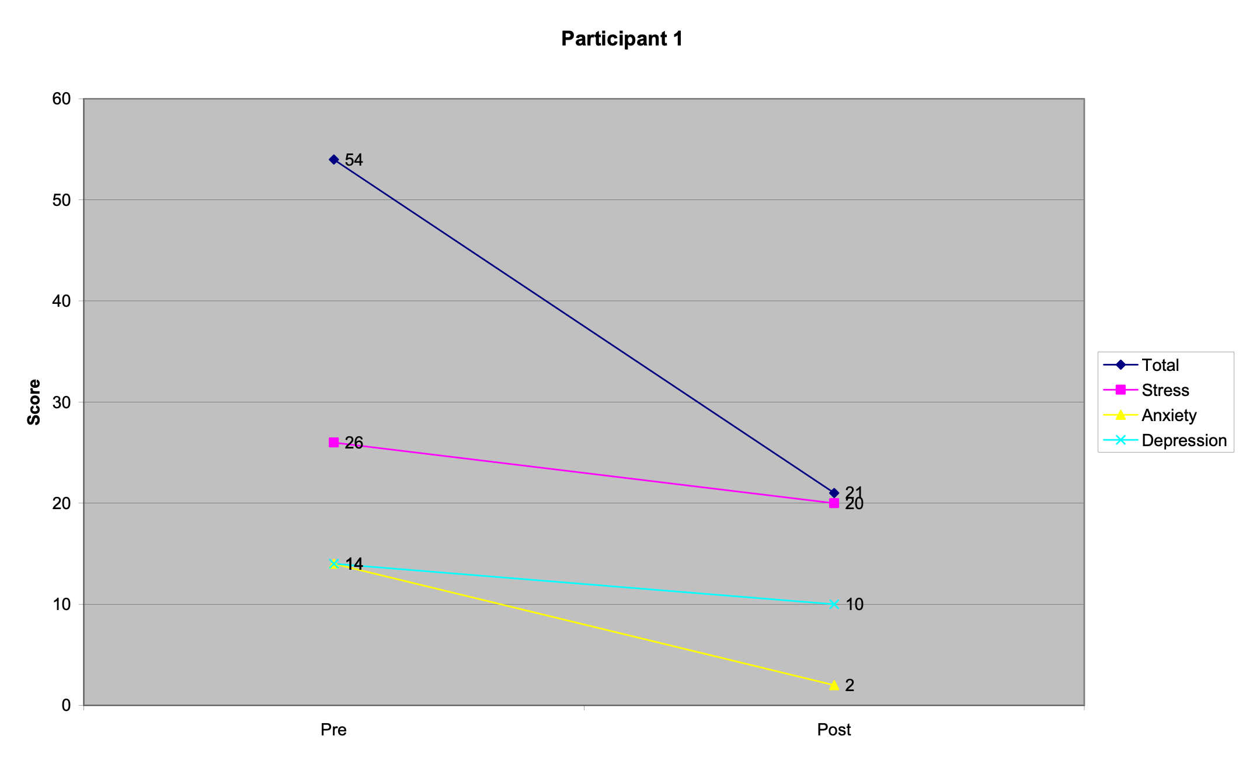

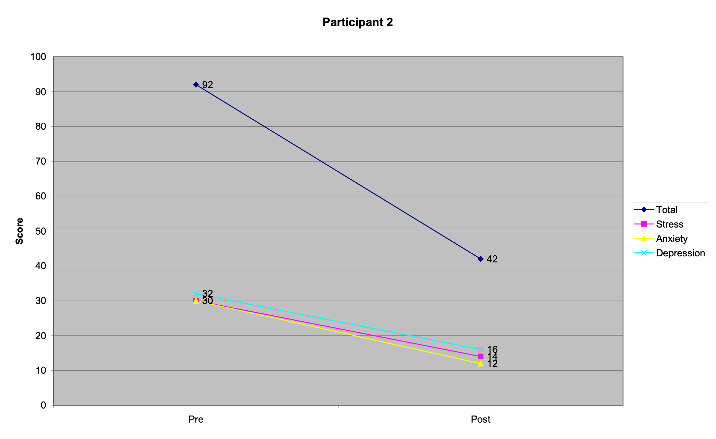
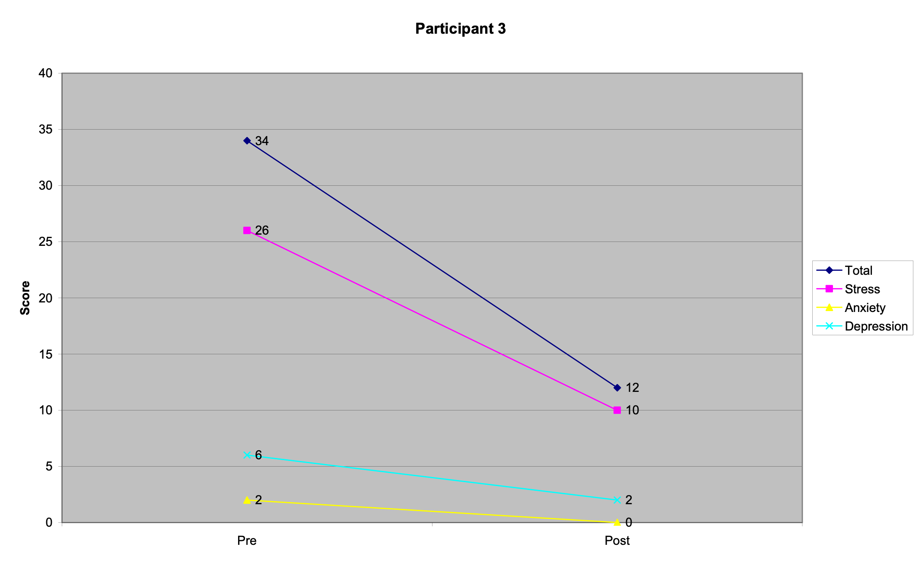

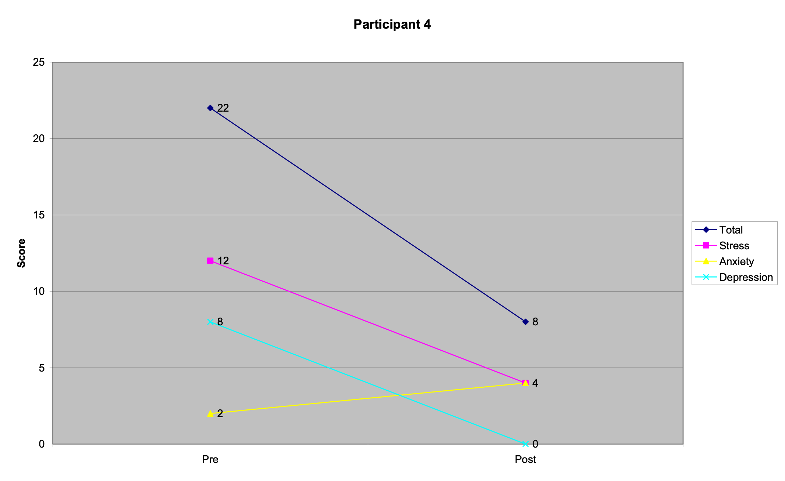
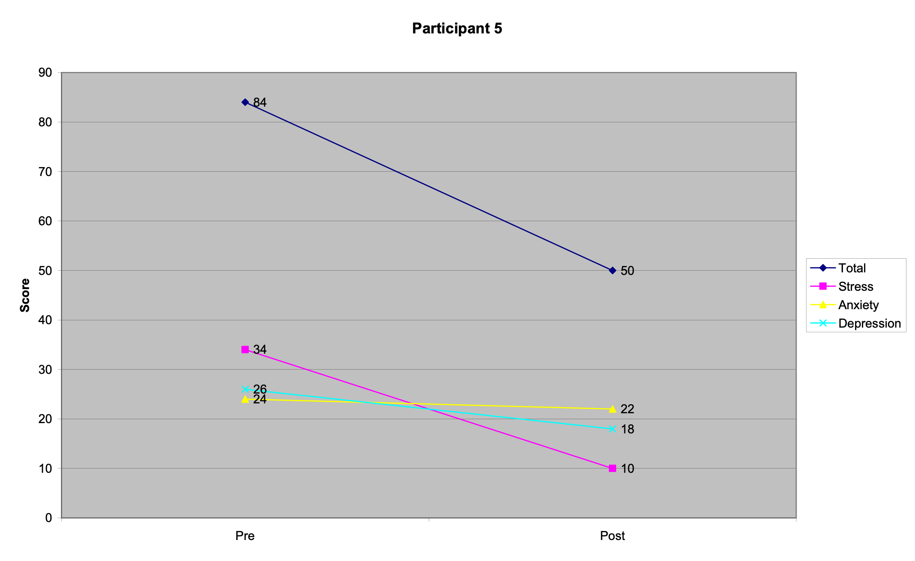

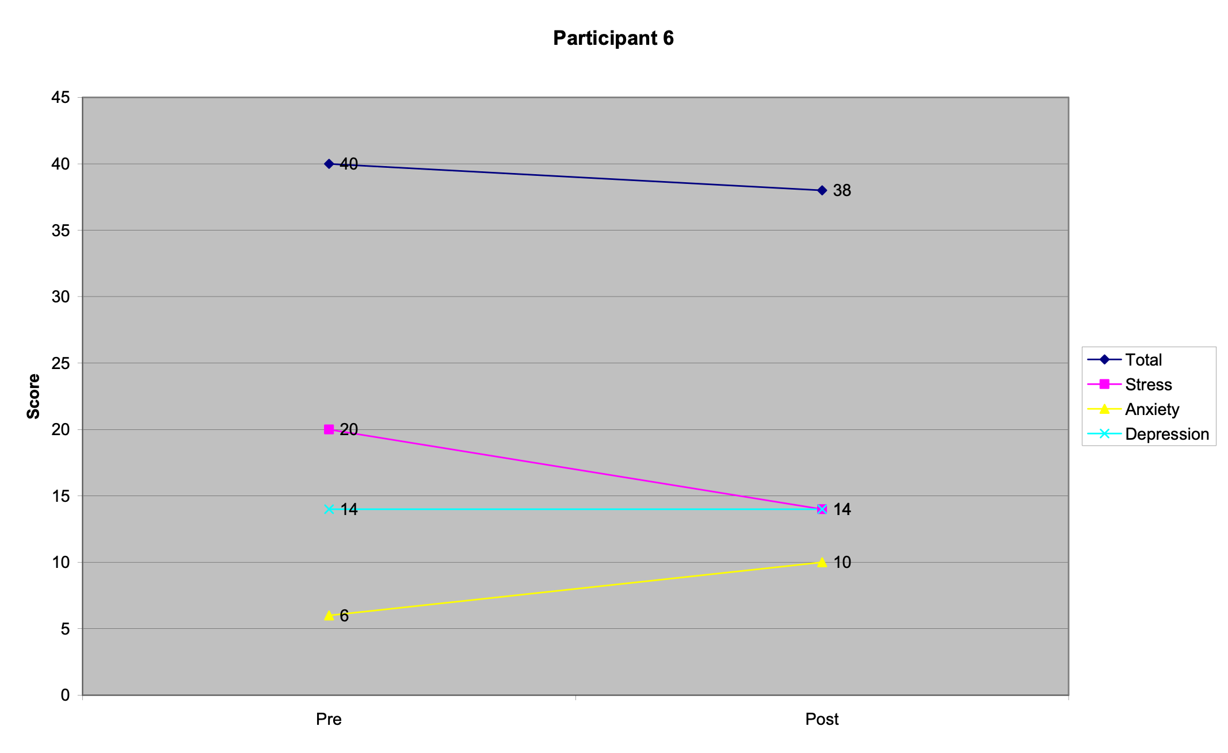

Melanie Chapman
20 February 2017

Henry, J. D., & Crawford, J. R. (2005). The short-form version of the depression anxiety stress scales (DASS-21): construct validity and normative data in a large non-clinical sample. British Journal of Clinical Psychology, 44(2), 227–239. http://www2.psy.unsw.edu.au/DASS/
Paired sample t tests were carried out to assess change. An alpha level of 0.05 was used to indicate statistical significance.

