Review of Local Government Business Model and Lists (esd Standards)
Contents
1. Introduction
2. List review
2. 1 Core Lists
Local Government Service List (LGSL)
2.2 People & Places Lists
Life Event List
Circumstance List
Need List
Metric Types List
Issues and Benefits List
2.3 Organisational Scope Lists
Function List
Power and Duty List (P&D)
Organisation Types List
2.4 Organisation Lists
Process List
Navigation List
Interaction List
Channel List
2.5 Other Lists
A to Z of Services List
Subject List
Procurement List
Entertainment List
Licence Applicant List
Licence Status List
2.6 Summary of recommended changes
3. Additional lists which might be added to the model
Area Types List
Period Types List
3.1 Summary of proposed revised LGBM
4. General recommendations to be considered during the review
4.1 Alternate labels
4.2 List metadata
4.3 Consultation process
4.4 User community

1. Introduction
This document covers the following:
- A review of each of the lists currently included in the ‘Local Government Business Model’ (LGBM) published at https://standards.esd.org.uk/. Most lists and relationships between them, are shown in the LGBM diagram below.

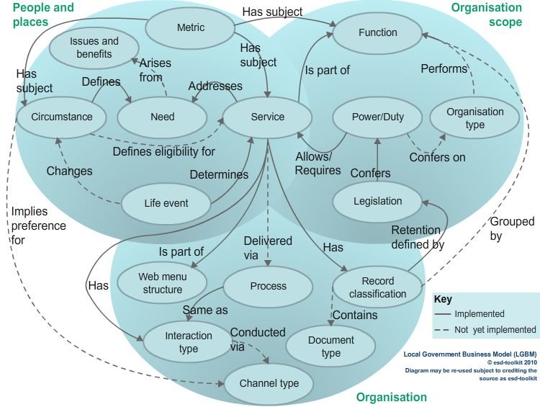

Note that the model above includes legislation and record classification which are not open data lists published in esd standards. They are included in the model because they link to published lists (service and power/duty).

The review of each list includes:
  - List name, description and purpose
  - View on the current status of the list
  - Recommendation on whether the list should be retained, deprecated or dropped
  - Recommendation on work required to bring a list to be retained up-to-date including mappings to other lists

- Proposals for lists which might be added to the model. For each list this includes:
  - List name, description and purpose
  - Approach to developing the list
  - Proposed mappings between the new list and other lists
- General recommendations to be considered during the review
  - Alternate labels
  - List metadata
  - Consultation process
  - User community

All lists describe “types” of thing although the word “types” is normally omitted from list names. Hence the Services List is a list of service types that can be assigned to specific services delivered by individual service providers.

2. List review
This section of the report makes recommendations for each of the existing lists in LGBM, classified by the area of the model in which they currently sit (or historically sat) .

2. 1 Core Lists

Local Government Service List (LGSL)

Description: Services delivered by local government (across all types of council plus Fire and Rescue Service organisations). The list includes both public facing services and internal services needed to run the business of a council/organisation. LGSL is a subset of the full ‘Services List’ which also includes subsets for ‘Internal Services’ and ‘Scottish Services (SSL)’

A service is: Something delivered by a government or other type of organisation to citizens and/or businesses to help the community, businesses or individual citizens. Services are delivered in accordance with legislation which empowers/permits or requires the organisation to deliver them.

Purpose: To provide a detailed list of the the types of service delivered by local authorities (LAs) which can be used for consistent recording and reporting of the activity within an authority and can be used to link service related information consistently across all LAs. The list was historically used for reporting to Central Government the extent to which each local authority’s services were e-enabled. It is used by some LAs for organising or checking the completeness of council websites. In conjunction with the transactions list LGSL is used to classify links from GOV.UK to specific service transaction pages on each council’s website, as illustrated by this open dataset of Local Directgov URL Instructions (the link is to an old dataset but a live equivalent remains in use by the Government Digital Service, GDS).

Referenced by schemas: LGSL references are used in open datasets compliant with these schemas: Inventory, Election results, Planning applications, Premises licences, Public toilets, Senior employees, Service directory

Current status: LGSL and the ‘Internal Services’ subsets are reviewed each year along with the Powers & Duties review plus ad hoc additions where required (eg on introduction of a requirement to report brownfield sites). Specific items of work such as the compilation and maintenance of Records of Processing Activity (RoPA) provide feedback on services. Both lists are up-to-date in accordance with legislation but have had minimal direct input from LA officers for some years. Last updated in March 2018.

Retain Y/N?: Yes - for LGSL and the Internal Services subset, these are essential for routine reporting and open data. Supported by the Local Digital Coalition. The Scottish Service List subset (SSL) should be deprecated as this is no longer used by Scottish LAs and is out of date.

Work required: Minimal to maintain for LAs. A review of names plus any services not currently mapped to powers/duties should be considered. We should consider if any services can be deprecated if legislation no longer applies or the services are not delivered in practice. The process for depreciating individual services needs to be established. A review is needed to verify there is consistent granularity for all areas of the list (e.g. for relatively recent public health services and for preventative services) and to make provision for services that are not directly associated with legislation. Contributions from expert local authority officers would help such a review. We need to agree the scope of the list to confirm if it should be extended to cover services provided by LA partners / other organisations where there is a link to LA service delivery / objectives.

2.2 People & Places Lists

Life Event List

Description: A list of events which might take place in a person’s life which could lead to them requiring services provided by a local authority. A life event can change an individual’s circumstances and so the the service types they might need.

A life event is: Something, generally unplanned, which happens during the life of an individual which may change their circumstances and lead to them needing one or more council services.

Purpose: To identify services relevant to a particular event happening.

Current status: Never progressed seriously beyond the draft stage. What is there is still relevant but mappings to service types and other lists are out of date. Last reviewed in October 2009.

Retain Y/N?: Drop. The links of circumstances to services remain relevant whether circumstances change as a result of a life event or not.

Required: Consultation to see if stakeholders have a need for a life events list.

Circumstance List

Description: A list of terms which might be used to identify the circumstances of an individual, household, community or place which might result in an application or need for LA or partner services.

A circumstance is: Something which describes the characteristics or lifestyle of an individual or something which is an attribute of a community or the place where someone lives or works.

Purpose: To filter the service types list down to services relevant to the circumstances of a customer searching for services. The list also provides descriptions of the dimensions of metrics (eg “Gender”) and their dimension members (eg “Female”) and thereby allows metrics and other information from a variety of sources to be referenced consistently.

Referenced by schemas: Service directory

Current status: Published in first draft with mappings to need and service type. The draft was focussed on health and social care so is not consistent in level of granularity/detail across the full service types list. Within health and social care some further detail is needed, e.g. we need to identify specific types of disability. The circumstance list fulfils three roles:
- Definition of general circumstances that combine with needs to indicate the type of service relevant to an individual
- Definition of eligibility criteria for specific services
- Definition of dimensions by which metrics defining people and places are broken down

Retain Y/N?: Yes - The content will depend on if/how work on the ‘Needs to service model’ progresses.

Work required: Review the draft and update it and its mappings to the need and service types lists. Consider ‘circumstance’ classifications from other lists for possible inclusion. Refine levels of details to meet the three roles defined above and update in the light of feedback from experience of the needs to service model. Consider level of detail needed - depends on how we see it being used. Maintain different overlapping subsets for circumstances defining metric dimensions and those related to need/services (and possibly eligibility). Would expect this list to be incrementally updated when working with any service directory project identifying the circumstances leading to a demand for services alongside any eligibility criteria.

Need List

Description: Terms which describe a specific need of an individual, organisation or place which might be addressed by the provision of one or more services. A need may arise from a circumstance.

A need is: Something which a person or a place requires to address/resolve an issue. Typically a need may be addressed by one or more services.

Purpose: In conjunction with circumstances, to identify types of service which might be relevant to an individual or place

Current status: Published in draft with mappings to circumstance (also draft) and to service(s) from LGSL.

Retain Y/N?: Yes - subject to a decision to progress the ‘Needs to service model’.

Work required: Refine in the light of experience gained in work with Lancashire and also look at current projects (Bristol, work on loneliness for Cabinet Office etc.). Need to consider whether this should be a ‘needs’ list or whether other terminology (e.g. ‘issues’) is more acceptable. The term ‘need’ is often avoided when looking at ‘social prescribing’. Incrementally improve by analysis of service directory services, what needs services aim to address and what they actually address.

Metric Types List

Description: Measures of demography, characteristics and performance for places and organisation at all levels of geography within England and Wales. Individual metric types have values published by many organisations and made available via LGA tools for specific types of area and time period. The list is currently divided into subsets for ‘Large area’ and ‘Small area’ which will be superseded by links to a new area types list for area types for which there are metric values available.

A metric type is: A measure of demography, characteristics and/or performance for an area

Purpose: Classification of the measures used for reporting in LG Inform and LG Inform Plus tools and providing a consistent public set of definitions for metrics that come from many sources.

Current status: Fully maintained via direct feed from LG Inform / Plus data routinely maintained by LGA via the Dataset Library tool

Retain Y/N?: Yes

Work required: No additional work

Issues and Benefits List

Description: – Potential benefits or issues that are addressed through the delivery of core local government processes and improvement initiatives.

An issue or benefit is: either a problem an individual or place currently has (an issue) or something which might improve the situation of an individual or place (benefit).

Purpose: To define issues affecting people or places and the potential benefits which can be achieved by delivering services.

Current status: Last updated in April 2013. Developed for a project looking at potential savings from specific initiatives (e.g. keeping people out of prison). Overlaps with ‘Needs’ and should be reviewed to see if there is anything that should be included in the ‘Needs’ list.

Retain Y/N?: Drop

Work required: Potentially none

2.3 Organisational Scope Lists

Function List
Description: Business functions which are usually performed by a local authority, covering all types of authority plus Fire and Rescue Service (FRS) organisations. Functions are in a hierarchical structure which reflects the business organisation structure of a typical council. Services in the LGSL are mapped to the Functions List and so grouped together by the business function group/department which would typically deliver each service.

A function is: an organisational unit or a grouping of services which are provided in a common area of interest.

Purpose: To group services in the LGSL in a way which facilitates searching and enables services to be allocated to the business unit which is involved in their delivery. This is used by tools such as records retention/RoPA, powers & duties in LG Inform Plus where a business unit may need to know and/or update details associated with the services it provides. The Functions List provide less granular definitions of service areas than LGSL services and so are more suitable for indexing data where just a broad service area needs to be referenced.

Referenced by schemas: Inventory, Land and building, Senior employees, Service directory
Current status: Last updated in September 2016

Retain Y/N?: Yes

Work required: Review terminology but keep the current structure for compatibility with other tools.

Power and Duty List (P&D)

Description: Legal powers and duties under which services are delivered. Determined by legislation. Covers all the legislation specifically empowering a local authority or FRS to provide a service and legislation specifically requiring it to deliver a service, but not legislation where the authority or FRS is acting in another capacity such as that of an employer or a landlord.

A power or duty is: Something which England and Wales legislation defines as the responsibility (duty) of a local authority (or FRS) to provide, or something which it has the authority (power) to provide within the area for which it is responsible.

Purpose: To provide LAs with an understanding of the services and supporting activities they are either required to deliver or allowed to provide according to current legislation. Powers/duties are mapped to the services in LGSL (and the internal service list) which result from the legislation. Note that not all services are mapped to legislation because some are provided by an LA in another capacity (employer, landlord etc.). There are also services which are commonly provided but for which there is no specific legislation (eg school libraries) and services which are driven by local Acts of Parliament (some licences for example) which are not included in the P&D list because they only apply to a single authority (or group of authorities) and current software does not allow for that situation.

The open ‘Powers and Duties’ list in the Standards pages is a list of the names and descriptions of each term in the list. Each is marked labelled as either a power or a duty. Additional information (links to legislation, applicable dates, responsible organisations etc.) for each term is provided in the ‘Powers and Duties’ tool available to LG Inform Plus subscribers.

Current status: Last revised in March 2018

Retain Y/N?: Yes

Work required: None other than the annual review for which provision is made in the LG Inform Plus contract. This assumes the scope of the list does not need to be extended beyond the current content. Extension to cover other powers and duties, for example those of landlords and employers, is not recommended.

Organisation Types List

Description: The types of organisation in both the public and the private sector which may work with local and central government organisations. The list uses the types of public sector organisation as defined at https://www.gov.uk/government/organisations

An organisation type is: a term used to group organisations which perform a common business function in both the public and private sectors within the UK. Organisations of a specific type are normally constituted according to the same legislation. Government organisations of a specific type normally govern areas or a specific type (eg country, local authority area).

Purpose: To identify the types of organisation which are involved in or work with Government in England & Wales and to match these to service types, record types and legislation (powers & duties). Organisations are assigned an organisation type so that tools in LG Inform Plus can identify the relevant data based on the organisation type of the user.

Referenced by schemas: Service directory

Current status: Updated in September 2016

Retain Y/N?: Yes

Work required: None other than routine annual review

Document type list

Description: Types of document which might form the records of a local authority

A document type is: a term which categorises documents according to their purpose e.g. specification, report, proposal etc.

Purpose: To identify the format of any document being stored (physically or electronically) by an organisation in order to facilitate searching.

Current status: This list, although currently still in the LGBM diagram, has already been dropped and is not therefore considered in this review.

Retain Y/N?: Already dropped

Work required: None

2.4 Organisation Lists

Process List
Description: List of the processes which take place throughout an organisation to deliver services. Includes both internal and customer facing processes.

A process is: a distinct set of steps through involved in delivery of a service. Typically service delivery is achieved by combining several processes in a specific order.

Purpose: To identify common elements of work that are combined in different ways o deliver different services. To allow an organisation to accurately quantify time spent in delivering a service (or responding to an enquiry) and use the time allocated against staff roles to cost activities.

Current status: Last updated in 2009.

Retain Y/N?: Drop. The list was created for a specific project around service costing and is no longer used. The “common processes” defined as tasks needed to deliver each service is subjective and the definitions used here have not been taken up elsewhere. iStandUK promotes the definition of “capabilities”, which Sedgemoor District Council has defined as requirements for it to deliver services by modular combination inter-connecting capabilities from a variety of suppliers. This approach may be seen as more valuable than definition of “processes”, but it is not proposed that any generic set of capabilities be published at this time.

Work required: None

Estimated time for recommended work:

Navigation List

Description: List of terms which might form the navigation structure for a local authority website. Based on the Function list and LGSL but using less formal terminology and taking the perspective of a member of the public. The list is poly-hierarchical as different members of the public may see one service as coming within different functional areas of a website.

A navigation item is: a term which identifies the purpose of a web page or group of pages

Purpose: To provide a standard structure for local authority websites, against which LAs might assess their own websites for improvement.

Current status: Developed by the West London Alliance of local authorities. Last updated in October 2013. Does not reflect more recent updates to LGSL and the latest functions list.

Retain Y/N?: Drop. There is now little demand for this list. With the increased use of search and the need for websites to work well with smartphones, a navigation list has decreased in importance. Significant rework would be needed to make it relevant today and there does not appear to be sufficient interest, as evidenced by a recent discussion on the matter by the Local Digital Coalition.

Work required: None

Interaction List

Description: List of the types of interaction that a customer might have when enquiring about or accessing council services.

An interaction is: the way in which a customer may interact with a local authority in relation to a service.
Purpose: To identify exactly what a customer needs in relation to a service. For example is it just an enquiry (providing information), an application, a payment etc.? Was used for best Value performance Indicator (BVPI) 157 to report the extent to which services were e-enabled via different channels. Now used by GDS in conjunction with LGSL to categorise local authority web page to which GOV.UK pages redirect. It is unlikely that GDS will request any updates, but existing links to interaction types should resolve correctly.

Current status: Not updated since 2005. Would probably still be relevant today.

Retain Y/N?: Deprecate. Used by GDS so should be deprecated rather than dropped.

Work required: None if deprecated.

Channel List

Description: The channels through which customers can access LA services mainly for information or to apply for a service. The channels concentrate on the way a customer can access a service rather than the channel through which a service may be delivered.

A channel is: The means by which a customer can communicate with a local authority for delivery of a service.

Purpose: Originally devised for BVPI 157 reporting which was about electronic delivery of services.

Current status: Last updated in December 2005. Would need complete revision to reflect the variety of channels now available which did not exist in 2005.

Retain Y/N?: Drop. No requirement for this list currently identified although channel shift is still a focus for some projects.

2.5 Other Lists

A to Z of Services List

Description: Alternative terms which may be used for items in LGSL and which may be used to construct an A to Z of services on a council website. For example waste may be referred to as ‘rubbish’, ‘refuse’, ‘garbage’ etc. The A-Z typically consists of one word terms which might be found in a longer LGSL service type name.

An A to Z term is: A short namer or alternative name for a service

Purpose: To make searching for terms in LGSL easier by making use of common vocabulary rather than relying on specific terms/names used in LGSL.

Current status: Out of date - has not been updated in line with recent reviews of LGSL. Last updated in March 2013.

Retain Y/N?: Drop. Move terms in A to Z to being alternate labels for corresponding LGSL services.

Work required: None if dropped

Subject List

Description: UK Cabinet Office Integrated Public Sector Vocabulary developed as an encoding scheme for populating the e-GMS (electronic Government Metadata Standard) and Dublin Core (DC) Subject element of metadata. IPSV has been hosted as part of esd standards for several years but has not been maintained or updated since 2006. The Cabinet Office has chosen to no longer maintain IPSV.

Purpose: To provide a subject description for documents and other resources to power searches and browder/narrower interrogation of online repositories.
Current status: Last updated to version 2 in April 2006. No longer updated but still used by some local authorities and academics. IPSV is no longer directly referenced and mandated within eGMS, allowing the publisher to consider if subject tagging is valuable, and to use the vocabulary that best describes their business. Therefore, the mandate to use IPSV no longer applies, although IPSV remains an option.

Retain Y/N?: Deprecate

Work required: None if deprecated

Procurement List

Description: ProClass is a procurement classification for local government. ProClass is maintained and published freely (although you have to pay for mappings to other procurement classifications) by Coding International.

Purpose: To classify spend into useful headings that will help identify savings and areas for collaboration, which in turn will lead to more efficient procurement and further savings.

Referenced by schemas: Expenditure

Current status: The version of Proclass on the esd standards pages is version 14 which was last updated in July 2014. The current version is 17.1 released in June 2017. Currently esd standards also publishes mappings between version 14 and other procurement classifications (CPV, NSV and others)

Retain Y/N?: Drop, redirecting users to the Coding International version. It is confusing to maintain two copies and there are no formal arrangements in place for the LGA copy to be maintained.

Work required: None, if dropped.

Entertainment List
Description: A list of the types of entertainment that may be specified within a premises licence.

An entertainment type is: a term from a list of entertainment types as defined in Schedule 1 of the Licensing Act 2003

Purpose: Defines type of entertainment which can be included when an application for a premises licence is being completed.

Referenced by schemas: Premises licence

Current status: Up to date with current legislation

Retain Y/N?: Yes

Work required: None

Licence Applicant List

Description: A list of the types of applicant for a premises licence.

A licence applicant type: identifies the type of premises for which an application for a licence is being made as defined in Section 16 of the Licensing Act 2003.

Purpose: Defines the applicant type which must be specified when an application for a premises licence is being completed.

Referenced by schemas: Premises licence

Current status: Up to date with current legislation

Retain Y/N?: Yes

Work required: None

Licence Status List

Description: A list of the types of status which can be applied to a premises licence.

A licence status: defines the current position of a licence and defines whether a licence is currently valid or not.

Purpose: Defines the status of any premises licence both during the application process, on completion of the application process and once a licence has been granted.

Referenced by schemas: Premises licence

Current status: Up to date with current legislation

Retain Y/N?: Yes

Work required: None

2.6 Summary of recommended changes
The diagram below shows the recommended actions for each of the lists in the current LGBM model:
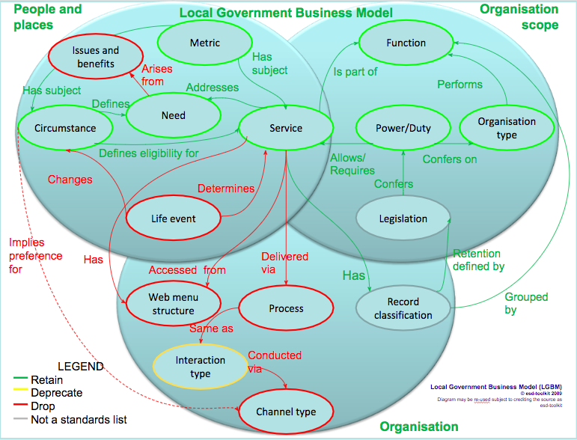

3. Additional lists which might be added to the model

Area Types List
Description: A list of types which can be assigned to official geographic areas to identify which areas can be compared with each other in a meaningful way.

An area type is: a term used to describe areas which belong to the same official geography.

Purpose: To link areas of a common geography such that they can be used for measurement and comparison between areas of the same area type.

Approach to developing the list: The list will include all official area types with “same as” relationships to the types maintained by ONS and Natural Neighbourhoods. Area types maintained by the Support Team (as opposed to other users) in Natural Neighbourhoods will be considered “Official”. Hence the list will automatically be updated to match periods defined in support of LGA reporting tools and area defined for reference in local open data.

Proposed mappings between the area types list and other lists: An area type is measured by a metric type.

Period Types List
Description: A list of the types of period over which metrics are measured.

A period type: Defines the frequency with which something is measured (e.g. population per calendar year) or the time period applicable to a measure (e.g. expenditure during a financial year).

Purpose: Every metric type has an associated period type. Reporting tools allow selection of a time period matching the period type associated with each metric type selected such that reports can be for the latest period or a previous selected period. Metrics with the same period can be compared. Rules can be defined for associating periods of different types (e.g. expenditure for a financial year by population head measured for with the closest matching calendar year).

Approach to developing the list: The list will include all period types returned by the period types web method. That web method returns all period types requested by the LGA’s Research and Information team to record metrics from approximately 50 different sources with a variety of different periods.

Proposed mappings between the period types list and other lists: A metric type has a period type.

3.1 Summary of proposed revised LGBM
The following diagram shows what the LGBM might look like following implementation of all the recommendations made plus the addition of the new lists described above:

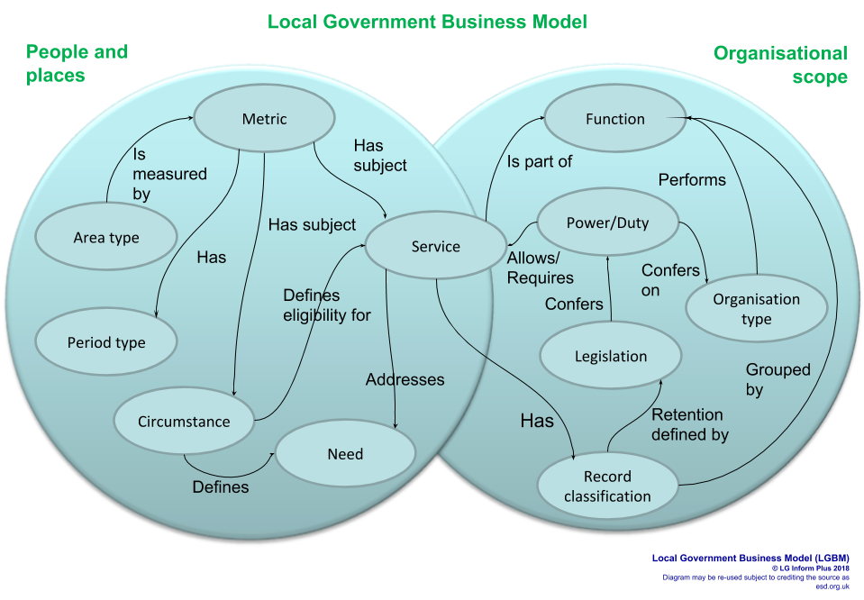

The revised model includes only the modules for ‘People and places’ and ‘Organisational scope’. Implementing the recommendations in this report resulted in all the lists from the ‘Organisation’ module being dropped or deprecated - with the exception of the ‘Record classification’ which has been moved into ‘Organisational scope’. The organisation module contained lists relating to the internal operation of an organisation whilst ‘Organisational scope’ covered topics which related to the customer facing business of an organisation. Records classification could fit into either of these as whilst the means of classification might be internal the publication of a retention schedule and RoPA which use the classification are public facing.

Note that the inclusion in the model of the ‘Need’ list and the ‘Circumstance’ list beyond the scope of metric dimensions (as used in LGI/LGIP) are dependent upon work on the ‘Needs to service model’ as a separate project.

3.2 Proposed mapping types between lists

From/to list | Predicate | To/from list
Area | Is measured by | Metric
 | measures
Circumstance | is described by | Metric
 | describes
Circumstance | indicates need | Need
 | arises from circumstance
Circumstance | Is addressed by to service | Service
 | addresses circumstance
Function | is performed by | Organisation
 | performs
Function | groups | Record
 | is grouped by
Function | is performed by | Service
 | is part of
Legislation | confers | Power/Duty
 | is conferred by
Legislation | defines retention for | Record
 | has retention defined by
Metric | has | Period
 | applies to
Metric | has subject | Service
 | is subject of
Need | is addressed by | Service
 | addresses
Organisation | has conferred | Power/Duty
 | is conferred on
Power/Duty | allows / requires | Service
 | Is allowed by / is required by
Record | documents | Service
 | has documents of

4. General recommendations to be considered during the review
This section of the report contains general recommendations which should be considered when reviewing each list plus recommendations regarding interaction and consultation with users both during review and for ongoing maintenance of the lists.

4.1 Alternate labels
At present lists have a single term name. It is recommended that we implement alternate names for most (if not all) lists and populate the alternate names wherever appropriate.

Specifically it is recommended that we drop the existing A to Z list and instead add the current A to Z terms, plus any others identified during the review, as alternate labels for LGSL and the Internal services lists.

As a separate piece of work we should consider whether LG Inform Plus searches could be enhanced to take advantage of the alternate labels.

4.2 List metadata
As we do with LGSL (see this page), we need to provide explicit quality metadata (e.g. on completeness and timeliness) for lists that will not be dropped. Quality metadata elements are defined by the document 'Designing URI sets for the UK public sector' and suggested in the W3C Web Best Practices Working Group wiki Quality and Granularity Description Vocabulary page. These give an indication as to who lists are aimed at, how much they can rely on them and any guarantees (eg best efforts, updated annually).

4.3 Consultation process
During this review and for ongoing maintenance of the lists some consultation with users of the lists is recommended, if not essential, to promote take up of the standards.

Historically, setting up and organising physical meetings of any ‘working group’ has proved onerous and not hugely successful.

A process whereby a taxonomist does the review and recommends changes which are then issued electronically in draft to take feedback is recommended and has previously proved more successful.

In addition other projects, for example RoPA or any potential Service Directory work, could be used to provide feedback and suggested enhancements to lists.

4.4 User community
To support a community of list users and assess usage it would be useful to:
- Allow people to register interest in each list and request notification of updates
- Record schemas that make reference to each list
- Record/detect datasets that reference list Uniform Resource Identifiers (URIs)

4.5 Miscellaneous small points
Every list describes a “type” of concept, so we can consistently drop “Type” from all list names.

Mappings to deprecated lists will no longer be shown or maintained. Existing mappings from deprecated lists will be shown.

A subset of the Circumstance list defines circumstances that might define eligibility for individual services (not service types).

The Record types list and its mappings to legislation are only published in human readable format as part of the Records Retention subscription tool.

The Mappings from Powers and Duties to legislation are only published as part of the Powers and Duties subscription tool.

Por10473

